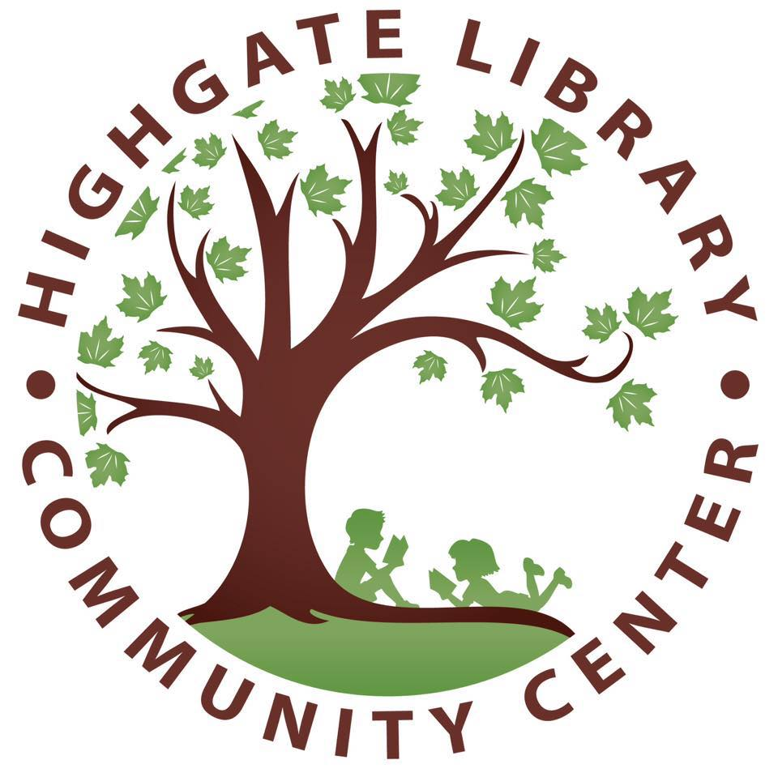
Highgate Library & Community Center Annual Craft/Vendor Show
@ The Highgate Elementary School
SATURDAY, NOVEMBER 21st, 2026
9:00am-3pm
219 Gore Road, Highgate Center, VT, 05459

Crafters may set up Friday, November 20th 5:30pm-7pm or Saturday, November 21stth beginning at 7:00 am. (Please note that HLCC is not responsible for lost or stolen items). Please bring your own tables – we will supply the chairs!
Cost: $30 per space
Apply for space by November 1st
Mail (or drop off) check or cash and application to the
Highgate Library & Community Center, PO Box 76 , Highgate Center, VT 05459.
Checks payable to Highgate Library & Community Center

If you have any questions or would like to be removed from our mailing list, please email us at HLCCfallshow@gmail.com – we will get back to you as soon as we can!

The sooner you get your application in -- the better chance you have of getting the spot you want!

Additional information:
-We will do our best to honor special needs and requests if possible, but cannot guarantee wall space or access to electrical outlets.
-We can not guarantee internet access.
-After unloading your vehicle, please move your car out to the back of the brick school.
-Please provide your own heavy-duty extension cords.
-Each crafter is asked to donate an item to our raffle table. Raffle tickets will be available during the normal craft show hours and all proceeds benefit the Highgate Library & Community Center.
-All crafters are asked to please stay until 3:00 p.m. to ensure an enjoyable and profitable craft show for everyone.
-Breakfast and coffee will be available by donation on Saturday 7am-9am
-Food Truck Lunching will be available for purchase from 11:00 a.m. - 2:00 p.m.

We are so looking forward to working with you, and are implementing some new ideas to improve the experience for everyone! If you have any questions or concerns please feel free to reach out to us!

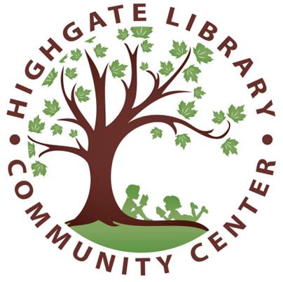
Highgate Library & Community
Center Annual Craft/Vendor Show
@ The Highgate Elementary School
November 21st, 2026

Application Form

Name: ________________________________________________________
E-mail: ________________________________________________________
Address: ___________________________________________________
Phone: _____________________________________________________________________
Social Media: ___________________________________________________________________
Website or Etsy Shop: __________________________________________________________
Description of products: ________________________________________________

______________________________________________________________________________________

______________________________________________________________________________________

We welcome you to the 22nd fall craft/vendor show at Highgate Elementary School. Our goal is to fundraise in support of the Highgate Library and Community Center, as well as to facilitate an inclusive community event. We will also be working with the Highgate Elementary School and several other not for profit local groups on their fundraising endeavors though this event.

In order to help you have a pleasant and profitable show, please provide the following information:

*Please note that tables will not be provided*

Number of spaces _______

Please circle your requests: outlets wall space lunch room library

any available space gym hallway office hallway lunchroom hallway

^^^^^^^^^^^^^^^^^^^^^^^^^^^^^^^^^^^^^^^^^^^^^^^^^^^^^^^^^^^^^^^^^^^^
OFFICE SPACE ONLY

Amount __________ Check # _________ Date received_______________

